Sorting algorithm
What is sorting :-
- arranging the element in some logical order. If element are number by default sorting means arranging element in ascending order.
- If element are string by default sorting means arranging the element in dict order.
Two types of sorting :-
- Internal sort :- if no extra memory is required other than ram to sort element of the array is called internal sort.
- External sort :- if extra memory is required other than ram to sort the element of the array is called external sort.
Sorting algorithm
- Bubble sort
- Modified Bubble sort
- Selection sort
- Insertion sort
- merge sort
- Quick sort
1.Bubble sort :-
What is Bubble Sort?
- Repeatedly compares adjacent elements
- Swaps them if they are in the wrong order
- Largest element “bubbles up” to the end in each pass
How Bubble Sort Works
Example:
Array: [5, 3, 2, 4]
Pass 1:
- Compare 5 and 3 → swap → [3, 5, 2, 4]
- Compare 5 and 2 → swap → [3, 2, 5, 4]
- Compare 5 and 4 → swap → [3, 2, 4, 5]
Pass 2:
- Compare 3 and 2 → swap → [2, 3, 4, 5]
- Compare 3 and 4 → no swap
- Compare 4 and 5 → no swap
Pass 3:
- Already sorted → no swaps
Code :-
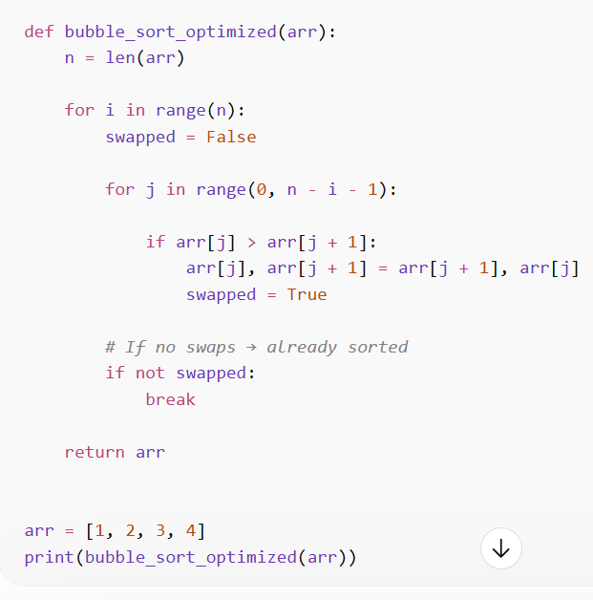

Time complexity : 0(n2)
Space Complexity :-0(1)

Selection sort :-
🔁 How It Works (Step-by-Step)
Example:
[5, 3, 8, 1]
Pass 1:
- Smallest = 1
- Swap with first element
👉 [1, 3, 8, 5]
Pass 2:
- Smallest in remaining = 3
👉 [1, 3, 8, 5]
Pass 3:
- Smallest = 5
👉 [1, 3, 5, 8]

🧩 3. Algorithm (Simple Steps)
- Start from index 0
- Find smallest element in the rest of array
- Swap with current index
- Move to next index
- Repeat until array is sorted
